EGR 402 – Capstone Design

Deliverable 6: Prototyping

Team Name: Blueprints

Team Members: Jordan Ziegler

  Jeremy Fischer

  Justus Karenzi

  Sudi Nsengiyumva

  Dylan Shanahan

Client’s Name: Dr. Mark Gordon

Advisor’s Name: Professor Thomas Renck

Version: 1

Date: Feb 9th, 2015

**6.1 Main Activity Design**

This acts as the homepage for the overall design (can be seen in Figure 1). Main_Menu.Java and activity_main_menu.xml can be found in Appendix A.

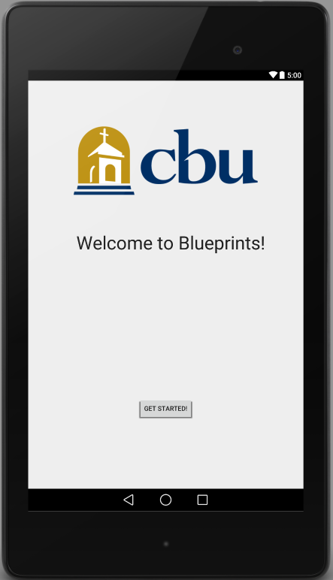

Figure 1 - Screenshot of Main_Menu output

**6.2 Subsequent Activity Designs**

Below is the description of the subsequent activities that follow the Main Activity page.

6.2.1 Building Selection Activity

This allows the user to select which building they are currently in. User interface can be seen below in Figure 2. Building_Selection.Java and activity_building_selection.xml can be found in Appendix B.

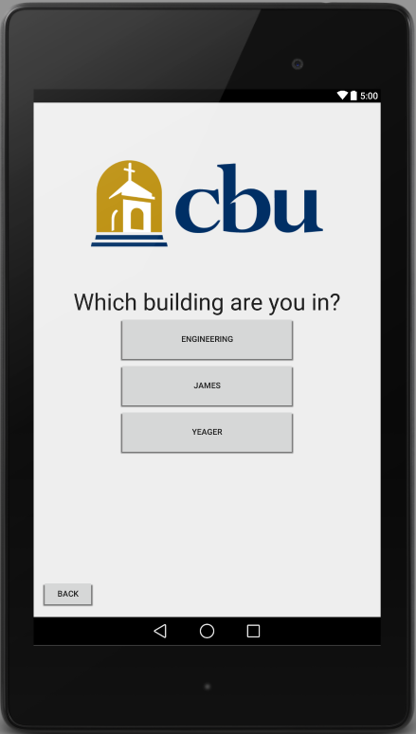

Figure 2 - Screenshot of Building_Selection output

6.2.2 Room Selection Activity

This allows the user to select which room they are attempting to navigate to. After the building is selected, the user is directed to the room selection page based on the building choice.

Room Selection Activity is broken down into three other activities based on user selection: Engineering, James, and Yeager. Engineering’s user interface can be seen below in Figure 3. James and Yeager’s user interface can be seen in Figure 4.

Engineering.Java and activity_engineering can be found in Appendix C.

James.Java, activity_james.xml, Yeager.Java, and activity_yeager.xml can be found in Appendix D.

*Due to James and Yeager not being important for this project the students have decided to not create pages for them but have included them for future versions.

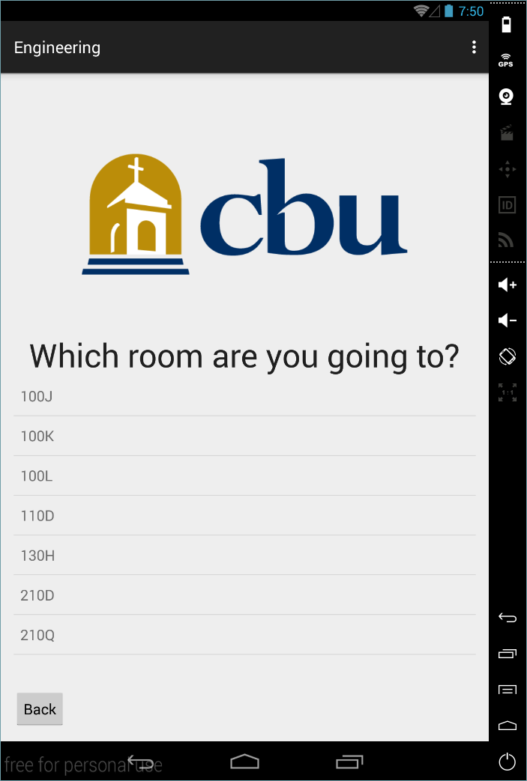

Figure 3 - Screenshot of Engineering output

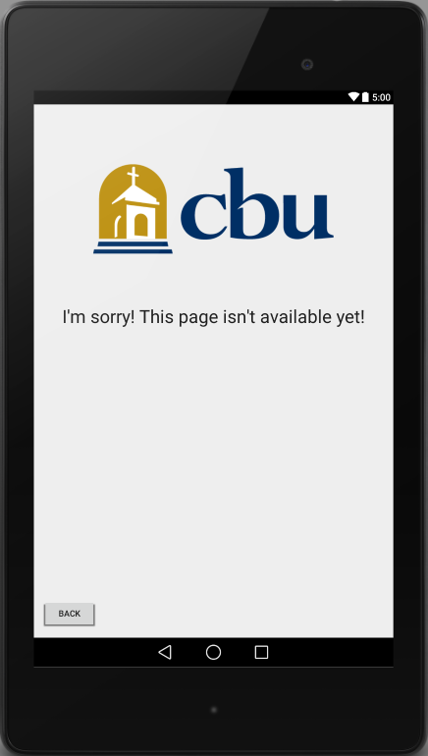

Figure 4 - Screenshot of James and Yeager output

6.2.3 Camera Interface

Camera Interface is currently in progress of being implemented. Due to these circumstances the unfinished code is not included.

**Appendices**

Appendix A

Main_Menu.Java

package com.example.dylan.app;

import android.content.Intent;

import android.support.v7.app.ActionBarActivity;

import android.os.Bundle;

import android.view.Menu;

import android.view.MenuItem;

import android.view.View;

import android.widget.Button;

public class Main_Menu extends ActionBarActivity {

@Override

protected void onCreate(Bundle savedInstanceState) {

super.onCreate(savedInstanceState);

setContentView(R.layout.activity_main_menu);

// Creates a simple button

Button btnSimple = (Button) findViewById(R.id.btnSimple);

btnSimple.setOnClickListener(new View.OnClickListener() {

@Override

public void onClick(View v) {

Intent intent = new Intent(v.getContext(), Building_Selection.class);

//jumps to Building_Selection Class

startActivityForResult(intent, 0);

}

});

}

@Override

public boolean onCreateOptionsMenu(Menu menu) {

// Inflate the menu; this adds items to the action bar if it is present.

getMenuInflater().inflate(R.menu.menu_main_menu, menu);

return true;

}

@Override

public boolean onOptionsItemSelected(MenuItem item) {

// Handle action bar item clicks here. The action bar will

// automatically handle clicks on the Home/Up button, so long

// as you specify a parent activity in AndroidManifest.xml.

int id = item.getItemId();

//noinspection SimplifiableIfStatement

if (id == R.id.action_settings) {

return true;

}

return super.onOptionsItemSelected(item);

}

}

activity_main_menu.xml

<RelativeLayout xmlns:android="http://schemas.android.com/apk/res/android"

xmlns:tools="http://schemas.android.com/tools" android:layout_width="match_parent"

android:layout_height="match_parent" android:paddingLeft="@dimen/activity_horizontal_margin"

android:paddingRight="@dimen/activity_horizontal_margin"

android:paddingTop="@dimen/activity_vertical_margin"

android:paddingBottom="@dimen/activity_vertical_margin" tools:context=".Main_Menu">

<Button android:id="@+id/btnSimple" android:layout_width="wrap_content"

android:layout_height="wrap_content" android:text="Get Started!"

android:layout_alignParentBottom="true"

android:layout_centerHorizontal="true"

android:layout_marginBottom="134dp"> </Button>

<ImageView

android:layout_width="wrap_content"

android:layout_height="wrap_content"

android:src="@drawable/cbu_logo"

android:layout_marginTop="75dp"

android:layout_alignParentTop="true"

android:layout_centerHorizontal="true"

android:id="@+id/imageView" />

<TextView

android:layout_width="wrap_content"

android:layout_height="wrap_content"

android:textAppearance="?android:attr/textAppearanceLarge"

android:text="Welcome to Blueprints!"

android:id="@+id/textView2"

android:layout_marginTop="72dp"

android:textSize="40sp"

android:layout_below="@+id/imageView"

android:layout_alignRight="@+id/imageView"

android:layout_alignEnd="@+id/imageView" />

</RelativeLayout>

Appendix B

Building_Selection.Java

package com.example.dylan.app;

import android.content.Intent;

import android.support.v7.app.ActionBarActivity;

import android.os.Bundle;

import android.view.Menu;

import android.view.MenuItem;

import android.view.View;

import android.widget.Button;

public class Building_Selection extends ActionBarActivity {

@Override

protected void onCreate(Bundle savedInstanceState) {

super.onCreate(savedInstanceState);

setContentView(R.layout.activity_building_selection);

Button btnSimple1 = (Button) findViewById(R.id.btnSimple1);

btnSimple1.setOnClickListener(new View.OnClickListener() {

@Override

public void onClick(View v) {

Intent intent = new Intent(v.getContext(), Main_Menu.class);

startActivityForResult(intent, 0);

}

});

Button btnSimple2 = (Button) findViewById(R.id.btnSimple2);

btnSimple2.setOnClickListener(new View.OnClickListener() {

@Override

public void onClick(View v) {

Intent intent = new Intent(v.getContext(), Engineering.class);

startActivityForResult(intent, 0);

}

});

Button btnSimple3 = (Button) findViewById(R.id.btnSimple3);

btnSimple3.setOnClickListener(new View.OnClickListener() {

@Override

public void onClick(View v) {

Intent intent = new Intent(v.getContext(), James.class);

startActivityForResult(intent, 0);

}

});

Button btnSimple4 = (Button) findViewById(R.id.btnSimple4);

btnSimple4.setOnClickListener(new View.OnClickListener() {

@Override

public void onClick(View v) {

Intent intent = new Intent(v.getContext(), Yeager.class);

startActivityForResult(intent, 0);

}

});

}

@Override

public boolean onCreateOptionsMenu(Menu menu) {

// Inflate the menu; this adds items to the action bar if it is present.

getMenuInflater().inflate(R.menu.menu_room__selection, menu);

return true;

}

@Override

public boolean onOptionsItemSelected(MenuItem item) {

// Handle action bar item clicks here. The action bar will

// automatically handle clicks on the Home/Up button, so long

// as you specify a parent activity in AndroidManifest.xml.

int id = item.getItemId();

//noinspection SimplifiableIfStatement

if (id == R.id.action_settings) {

return true;

}

return super.onOptionsItemSelected(item);

}

}

activity_building_selection.xml

<RelativeLayout xmlns:android="http://schemas.android.com/apk/res/android"

xmlns:tools="http://schemas.android.com/tools" android:layout_width="match_parent"

android:layout_height="match_parent" android:paddingLeft="@dimen/activity_horizontal_margin"

android:paddingRight="@dimen/activity_horizontal_margin"

android:paddingTop="@dimen/activity_vertical_margin"

android:paddingBottom="@dimen/activity_vertical_margin"

tools:context="com.example.dylan.app.Room_Selection">

<ImageView

android:layout_width="wrap_content"

android:layout_height="wrap_content"

android:src="@drawable/cbu_logo"

android:layout_marginTop="75dp"

android:layout_alignParentTop="true"

android:layout_centerHorizontal="true"

android:id="@+id/imageView" />

<Button android:id="@+id/btnSimple1"

android:layout_width="wrap_content"

android:layout_height="wrap_content"

android:text="Back"

android:layout_alignParentBottom="true"

android:layout_alignParentLeft="true"

android:layout_alignParentStart="true"> </Button>

<Button android:id="@+id/btnSimple2"

android:layout_width="300sp"

android:layout_height="80sp"

android:text="Engineering"

android:layout_below="@+id/buildingInquiry"

android:layout_centerHorizontal="true"/>

<Button android:id="@+id/btnSimple3"

android:layout_width="300sp"

android:layout_height="80sp"

android:text="James"

android:layout_below="@+id/btnSimple2"

android:layout_centerHorizontal="true"/>

<Button android:id="@+id/btnSimple4"

android:layout_width="300sp"

android:layout_height="80sp"

android:text="Yeager"

android:layout_below="@+id/btnSimple3"

android:layout_centerHorizontal="true"/>

<TextView

android:layout_width="wrap_content"

android:layout_height="wrap_content"

android:textAppearance="?android:attr/textAppearanceLarge"

android:text="Which building are you in?"

android:id="@+id/buildingInquiry"

android:layout_below="@+id/imageView"

android:layout_centerHorizontal="true"

android:layout_marginTop="63dp"

android:textSize="40sp" />

</RelativeLayout>

Appendix C

Engineering.Java

package com.example.dylan.app;

import android.content.Intent;

import android.support.v7.app.ActionBarActivity;

import android.os.Bundle;

import android.view.Menu;

import android.view.MenuItem;

import android.view.View;

import android.widget.AdapterView;

import android.widget.ArrayAdapter;

import android.widget.Button;

import android.widget.ListAdapter;

import android.widget.ListView;

public class Engineering extends ActionBarActivity {

@Override

protected void onCreate(Bundle savedInstanceState) {

super.onCreate(savedInstanceState);

setContentView(R.layout.activity_engineering);

String[] classrooms = {"100J","100K","100L","110D","130H","210D","210Q"};

ListAdapter theAdapter = new ArrayAdapter<String>(this,android.R.layout.simple_list_item_1,classrooms);

ListView listView = (ListView) findViewById(R.id.listView);

listView.setAdapter(theAdapter);

listView.setOnItemClickListener(new AdapterView.OnItemClickListener() {

@Override

public void onItemClick(AdapterView<?> parent, View v, int i, long id) {

Intent intent = new Intent(v.getContext(), Yeager.class);

startActivityForResult(intent, 0);

}

});

Button btnSimple1 = (Button) findViewById(R.id.btnSimple1);

btnSimple1.setOnClickListener(new View.OnClickListener() {

@Override

public void onClick(View v) {

Intent intent = new Intent(v.getContext(), Building_Selection.class);

startActivityForResult(intent, 0);

}

});

}

@Override

public boolean onCreateOptionsMenu(Menu menu) {

// Inflate the menu; this adds items to the action bar if it is present.

getMenuInflater().inflate(R.menu.menu_engineering, menu);

return true;

}

@Override

public boolean onOptionsItemSelected(MenuItem item) {

// Handle action bar item clicks here. The action bar will

// automatically handle clicks on the Home/Up button, so long

// as you specify a parent activity in AndroidManifest.xml.

int id = item.getItemId();

//noinspection SimplifiableIfStatement

if (id == R.id.action_settings) {

return true;

}

return super.onOptionsItemSelected(item);

}

}

activity_engineering.xml

<RelativeLayout xmlns:android="http://schemas.android.com/apk/res/android"

xmlns:tools="http://schemas.android.com/tools" android:layout_width="match_parent"

android:layout_height="match_parent" android:paddingLeft="@dimen/activity_horizontal_margin"

android:paddingRight="@dimen/activity_horizontal_margin"

android:paddingTop="@dimen/activity_vertical_margin"

android:paddingBottom="@dimen/activity_vertical_margin"

tools:context="com.example.dylan.app.Engineering">

<ImageView

android:layout_width="wrap_content"

android:layout_height="wrap_content"

android:src="@drawable/cbu_logo"

android:layout_marginTop="75dp"

android:layout_alignParentTop="true"

android:layout_centerHorizontal="true"

android:id="@+id/imageView" />

<Button android:id="@+id/btnSimple1"

android:layout_width="wrap_content"

android:layout_height="wrap_content"

android:text="Back"

android:layout_alignParentBottom="true"

android:layout_alignParentLeft="true"

android:layout_alignParentStart="true"> </Button>

<TextView

android:layout_width="wrap_content"

android:layout_height="wrap_content"

android:textAppearance="?android:attr/textAppearanceLarge"

android:text="Which room are you going to?"

android:id="@+id/roomInquiry"

android:layout_below="@+id/imageView"

android:layout_centerHorizontal="true"

android:layout_marginTop="63dp"

android:textSize="40sp" />

<ListView

android:layout_width="wrap_content"

android:layout_height="wrap_content"

android:id="@+id/listView"

android:layout_below="@+id/roomInquiry"

android:layout_alignParentLeft="true"

android:layout_alignParentStart="true"

android:layout_above="@+id/btnSimple1"

android:choiceMode="singleChoice" />

</RelativeLayout>

Appendix D

James.Java

package com.example.dylan.app;

import android.content.Intent;

import android.support.v7.app.ActionBarActivity;

import android.os.Bundle;

import android.view.Menu;

import android.view.MenuItem;

import android.view.View;

import android.widget.Button;

public class James extends ActionBarActivity {

@Override

protected void onCreate(Bundle savedInstanceState) {

super.onCreate(savedInstanceState);

setContentView(R.layout.activity_james);

Button btnSimple = (Button) findViewById(R.id.btnSimple);

btnSimple.setOnClickListener(new View.OnClickListener() {

@Override

public void onClick(View v) {

Intent intent = new Intent(v.getContext(), Building_Selection.class);

startActivityForResult(intent, 0);

}

});

}

@Override

public boolean onCreateOptionsMenu(Menu menu) {

// Inflate the menu; this adds items to the action bar if it is present.

getMenuInflater().inflate(R.menu.menu_james, menu);

return true;

}

@Override

public boolean onOptionsItemSelected(MenuItem item) {

// Handle action bar item clicks here. The action bar will

// automatically handle clicks on the Home/Up button, so long

// as you specify a parent activity in AndroidManifest.xml.

int id = item.getItemId();

//noinspection SimplifiableIfStatement

if (id == R.id.action_settings) {

return true;

}

return super.onOptionsItemSelected(item);

}

}

activity_james.xml

<RelativeLayout xmlns:android="http://schemas.android.com/apk/res/android"

xmlns:tools="http://schemas.android.com/tools" android:layout_width="match_parent"

android:layout_height="match_parent" android:paddingLeft="@dimen/activity_horizontal_margin"

android:paddingRight="@dimen/activity_horizontal_margin"

android:paddingTop="@dimen/activity_vertical_margin"

android:paddingBottom="@dimen/activity_vertical_margin"

tools:context="com.example.dylan.app.James">

<ImageView

android:layout_width="wrap_content"

android:layout_height="wrap_content"

android:src="@drawable/cbu_logo"

android:layout_marginTop="75dp"

android:layout_alignParentTop="true"

android:layout_centerHorizontal="true"

android:id="@+id/imageView" />

<TextView

android:layout_width="wrap_content"

android:layout_height="wrap_content"

android:textAppearance="?android:attr/textAppearanceLarge"

android:text="I&apos;m sorry! This page isn&apos;t available yet!"

android:id="@+id/textView"

android:layout_below="@+id/imageView"

android:layout_centerHorizontal="true"

android:layout_marginTop="78dp"

android:textSize="30sp" />

<Button android:id="@+id/btnSimple"

android:layout_width="wrap_content"

android:layout_height="wrap_content"

android:text="Back"

android:layout_alignParentBottom="true"

android:layout_alignParentLeft="true"

android:layout_alignParentStart="true"> </Button>

</RelativeLayout>

Yeager.Java

package com.example.dylan.app;

import android.content.Intent;

import android.support.v7.app.ActionBarActivity;

import android.os.Bundle;

import android.view.Menu;

import android.view.MenuItem;

import android.view.View;

import android.widget.Button;

public class Yeager extends ActionBarActivity {

@Override

protected void onCreate(Bundle savedInstanceState) {

super.onCreate(savedInstanceState);

setContentView(R.layout.activity_yeager);

Button btnSimple = (Button) findViewById(R.id.btnSimple);

btnSimple.setOnClickListener(new View.OnClickListener() {

@Override

public void onClick(View v) {

Intent intent = new Intent(v.getContext(), Building_Selection.class);

startActivityForResult(intent, 0);

}

});

}

@Override

public boolean onCreateOptionsMenu(Menu menu) {

// Inflate the menu; this adds items to the action bar if it is present.

getMenuInflater().inflate(R.menu.menu_yeager, menu);

return true;

}

@Override

public boolean onOptionsItemSelected(MenuItem item) {

// Handle action bar item clicks here. The action bar will

// automatically handle clicks on the Home/Up button, so long

// as you specify a parent activity in AndroidManifest.xml.

int id = item.getItemId();

//noinspection SimplifiableIfStatement

if (id == R.id.action_settings) {

return true;

}

return super.onOptionsItemSelected(item);

}

}

activity_yeager.xml

<RelativeLayout xmlns:android="http://schemas.android.com/apk/res/android"

xmlns:tools="http://schemas.android.com/tools" android:layout_width="match_parent"

android:layout_height="match_parent" android:paddingLeft="@dimen/activity_horizontal_margin"

android:paddingRight="@dimen/activity_horizontal_margin"

android:paddingTop="@dimen/activity_vertical_margin"

android:paddingBottom="@dimen/activity_vertical_margin"

tools:context="com.example.dylan.app.Yeager">

<ImageView

android:layout_width="wrap_content"

android:layout_height="wrap_content"

android:src="@drawable/cbu_logo"

android:layout_marginTop="75dp"

android:layout_alignParentTop="true"

android:layout_centerHorizontal="true"

android:id="@+id/imageView" />

<TextView

android:layout_width="wrap_content"

android:layout_height="wrap_content"

android:textAppearance="?android:attr/textAppearanceLarge"

android:text="I&apos;m sorry! This page isn&apos;t available yet!"

android:id="@+id/textView"

android:layout_below="@+id/imageView"

android:layout_centerHorizontal="true"

android:layout_marginTop="78dp"

android:textSize="30sp" />

<Button android:id="@+id/btnSimple"

android:layout_width="wrap_content"

android:layout_height="wrap_content"

android:text="Back"

android:layout_alignParentBottom="true"

android:layout_alignParentLeft="true"

android:layout_alignParentStart="true"> </Button>

</RelativeLayout>